3.33: a) From Eq. (3.31), 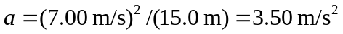. The acceleration at the bottom of the circle is toward the center, up.
b)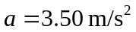, the same as part (a), but is directed down, and still towards the center. c) From Eq. (3.29), .

